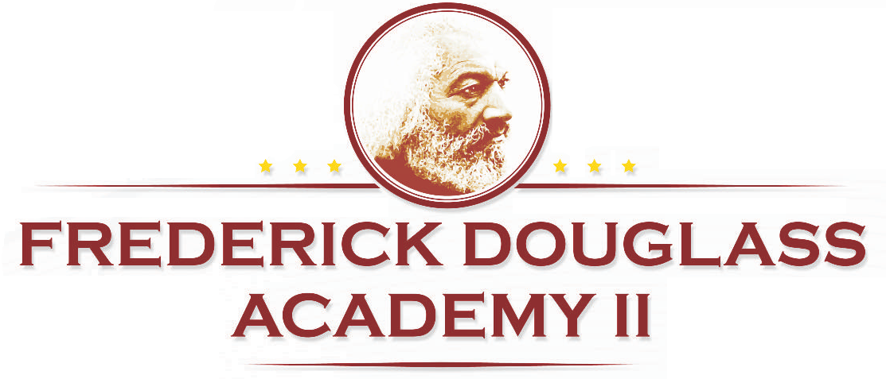
Computer Technology Lesson Plan

Name: Date:
Unit: Microsoft Word
Topic: Literary Scavenger Hunt
Aim: Scholars will search the Web for information on at least 10 literary classics.

Do Now
Introduction
If the phrase "classic literature" makes you think of dusty old books, think again. How about word-searchable Web sites? Electronic library? Now that classics have been brought into the digital age, they are even more accessible and you can interact with them in new ways. In this activity, you and one other classmate will team up in a literary scavenger hunt of English classics on the Web. You'll have just 1 class period to do your research, using the list of questions given to you and your teammate.
IF you complete it you get a TREAT!

Literary Scavenger Hunt
In this time-limited activity, you and your teammate will research the answers to your scavenger hunt.

Let’s begin
As you find your answers, enter them as paragraphs directly beneath the questions. Keep your answers brief—no more than a few sentences. At the end of each answer, include the full URL of the location where you found it.

Start your search at these Web sites:
- Bibliomania (http://www.bibliomania.com/0/0/frameset.html). Search 2,000 full classic texts by author or title. The site’s Author pages contain recommended links to more literary classics information.
- Classics at the online literature library (http://www.literature.org/authors/). Read the full text of many classics.
- American Literary Classics (http://www.americanliterature.com/ARCHIVES/ARCHIVES.HTML). Full text of more classics not available on other sites.
- University of Delaware Library Guide to English and American Literature (http://www2.lib.udel.edu/subj/engl/internet.htm). You can find more great links to e-texts here.
- Library of Congress (http://lcweb.loc.gov/homepage/lchp.html). Search the stacks by subject, title, or author.

Track down the answers to your scavenger hunt questions:
- Name two novels by Ernest Hemingway. When were they were published?
- Who wrote Travels with Charlie? Describe Charlie.
- Who wrote The Lord of the Flies? Briefly describe the setting and theme.
- What do the protagonists in The Scarlet Letter and Fahrenheit 451 have in common?
- What is the nature of the conflict in To Kill A Mockingbird?
- Who wrote 1984? What is the protagonist's greatest fear?
- Name two plays by Arthur Miller. Give a one-sentence description of each.
- Where does a symbol of God appear in The Great Gatsby?
- Who is the narrator of Mary Shelley's epistolary novel Frankenstein? What is the basic conflict in this story?
- Name a nature writer from the school of American Romanticism.
- Who wrote the novel Jane Eyre?
- What was the name of the periodical that Charles Dickens published Great Expectations in from 1860-1861 in serial form?
- In which chapters do you find the two famous death scenes in Uncle Tom's Cabin? Who dies in each scene?
- In his memoir A Narrative of the Life of Frederick Douglass, Douglass identifies what enabled him to free himself and work to free other slaves. What is it?
- What year was Jane Austen's Pride and Prejudice first published? What year was it first published under her name instead of as "Anonymous"?
- Who is the one man Buck will not steal from in Jack London's Call of the Wild? Why won't he steal from him?
- Name three classic American novels that were banned and the (first) date they were banned.

