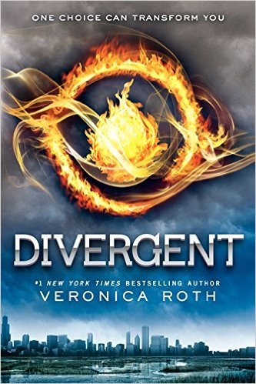
Divergent by Veronica Roth
Divergent is about a girl called Tris. She lives in a world which has a divided society. Tris doesn't fit in to any of the societies, she is different. She is forced to live a life she doesn't want. She wants to find where she belongs, so she leaves her family behind and ventures out alone. However, she finds herself in a brutal new life where she can trust nobody. Along this journey she becomes drawn to a boy who seemed dangerous but safe.
The book was very intriguing from the very start to the end. The plot line was unique and kept me reading. Many people say it is just like The Hunger Games, but I have read and enjoyed both books and I can tell you they are very different.
Divergent was based around many different aspects, but what I liked the most about this book was that it displayed not only the relationship that Tris had with Four, but it was also based on her friendship with the other characters and her family. I feel like other books are generally based around one relationship and don't really show the character's relationship with their friends and family as much as Divergent did, and that's what I think made Divergent a great book to read.
Tris was a very strong character and it was very interesting to read about her because she had her own mind and did not follow rules. She was a very determined character which made it so much better to read. And to top it all off there was a bit of romance in the book, which made it even better to read.
I would recommend this book to people who enjoy adventure books and love books like The Hunger Games.
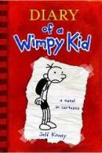
Diary of a Wimpy Kid by Jeff Kinney
Greg Heffley gets a journal from his mom ("a JOURNAL, not a diary") and records a middle school year's worth of crazy kid schemes, brushes with bullies, bad units in gym class, bids for student government, school play humiliation, and more.
Everything Greg seems to do has hilarious consequences and his family are very funny. In this book it is summer vacation and even though it is nice and hot Greg insists on staying inside hooked up to his video games with the blinds drawn. His mother is tired of Greg being lazy and decides that this summer should be fun and packed with family activities.
This book was very good. My favorite character has to be Greg as he can be horrible but the audience always roots for him anyway! I really like the part when Greg's mum is forgotten by the whole family at a petrol station in the middle of nowhere - it is hilarious.
I recommend this book to readers around 10-13 who enjoy reading as it is quite easy to read, but it has some challenging words as well. I give this a big 5/5 because I enjoyed reading it so much.

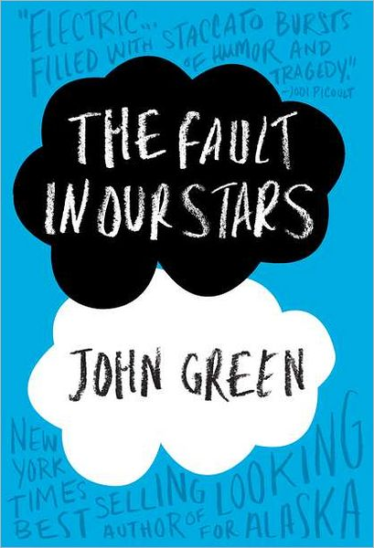
The Fault in Our Stars by John Green
Despite the tumor-shrinking medical miracle that has bought her a few years, Hazel has never been anything but terminal, her final chapter inscribed upon diagnosis. But when a gorgeous plot twist named Augustus Waters suddenly appears at Cancer Kid Support Group, Hazel’s story is about to be completely rewritten. Insightful, bold, irreverent, and raw, The Fault in Our Stars is award-winning-author John Green’s most ambitious and heartbreaking work yet, brilliantly exploring the funny, thrilling, and tragic business of being alive and in love.
Be prepared: This is a tearjerker dealing with dying -- and surviving the death of a loved one. Parents who read this book along with their teens will be particularly moved by Hazel's parents, who soothe her anxiety by telling her about their plans for after she has died, "Even when you die, I will still be your mom, Hazel ... how could I stop loving you?". Green wrote this book after making a friendship with a teen with cancer, and his attention to detail is remarkable, from descriptions of equipment to what it feels like to be stared at by well-meaning strangers. Readers may be perplexed about an alcoholic author who begins making appearances in Hazel's life, and may be unsure if he is really there or just a symbol. This decision seems a bit out of step with what is otherwise a realistic and emotionally harrowing book about love and loss. But Hazel's honest narration and her strength to love despite the consequences will capture teens' attention most. In the end, this is a painful book, but well worth it.

The Lightning Thief by Rick Riordan
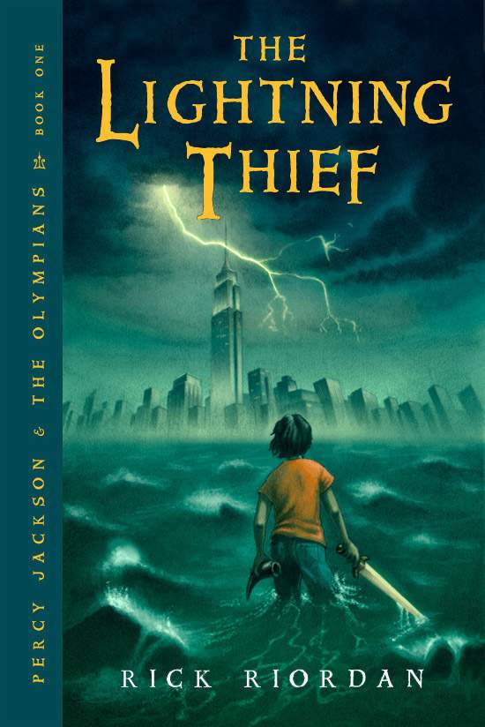
Always trouble-prone, the life of teenager Percy Jackson gets a lot more complicated when he learns he's the son of the Greek god Poseidon. At a training ground for the children of deities, Percy learns to harness his divine powers and prepare for the adventure of a lifetime: he must prevent a feud among the Olympians from erupting into a devastating war on Earth, and rescue his mother from the clutches of Hades, god of the underworld.

Written from Percy's point of view in choppy, attitude-filled prose, there are two levels of fun in THE LIGHTING THIEF. One is the fast-paced quest of a young hero and his friends to save the world. The characters aren't emotionally involving, but nonetheless this part is exciting, suspenseful, and very satisfying. Children who don't know much mythology can still enjoy the breakneck adventure on its own.
For those who do know Greek myths, or those inspired to learn about them, there's another level of fun here -- laughing at the wicked ways the author has updated the gods and monsters for the 21st century. Ares is a cross between a Hell's Angel and a professional wrestler, a math teacher is a harpy in disguise, and demigods can communicate by IMing -- Iris messaging (you'll have to read it to get the details on that one). A fun read for anyone, and a great read-aloud for a class studying mythology.

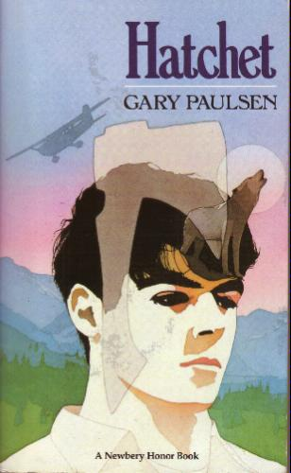
Hatchet by Gary Paulsen
Thirteen-year-old Brian Robeson is on his way to visit his father when the single-engine plane in which he is flying crashes. Suddenly, Brian finds himself alone in the Canadian wilderness with nothing but a tattered Windbreaker and the hatchet his mother gave him as a present—and the dreadful secret that has been tearing him apart since his parent’s divorce. But now Brian has no time for anger, self-pity, or despair—it will take all his know-how and determination, and more courage than he knew he possessed, to survive.
Muscular prose, plus an accurate depiction of the necessities of survival from an author who has lived the details, makes this a riveting, intelligent read. HATCHET has won dozens of awards and appears on many summer-reading lists -- and for good reason. In the end, the book is a fascinating thrill that will keep readers mesmerized to the last page.
Gary Paulsen does not romanticize the difficulties Brian faces. Readers witness his gut-wrenching sickness from eating too many berries and his shock when he realizes he has never before heard total silence. His failures and triumphs are also presented as equal parts of one life-altering experience. In the two months he spends in the wild, Brian undergoes countless emotional and physical changes. But Paulsen keeps the reader at Brian's side as he discovers how strong he has always been.

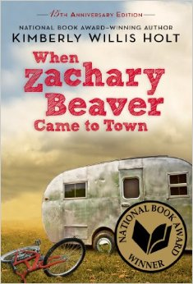
When Zachary Beaver Came to Town by Kimberly Willis Holt
Toby Wilson is having the toughest summer of his life. It's the summer his mother leaves for good; the summer his best friend's brother returns from Vietnam in a coffin. And the summer that Zachary Beaver, the fattest boy in the world, arrives in their sleepy Texas town. While it's a summer filled with heartache of every kind, it's also a summer of new friendships gained and old friendships renewed. And it's Zachary Beaver who turns the town of Antler upside down and leaves everyone, especially Toby, changed forever.
Holt sets her heartwarming and carefully crafted novel during 1971, but her message of tolerance is one that contemporary readers will appreciate. The moment Zachary Beaver, "the fattest boy in the world," rolls into Antler, Tex., in a trailer, 13-year-old Toby Wilson stands in line with his $2 in hand, waiting for a peek. Toby can't imagine what life is like inside the cramped trailer for the 643-pound boy. When Zachary's guardian suddenly takes off, leaving himÄand the trailerÄin the Dairy Maid parking lot, Toby and his best friend, Cal, become his caretakers of sorts, and eventually, his friend. Through this friendship, Toby learns sympathy and respectÄnot just for the misfit boy but for his own recently estranged parents and a string of other quirky characters who struggle with personal tragedies. While a few of the plot points feel predictable, the well-developed characters, all fantastic and flawed in their own ways, add plenty of spice. There's Toby's mother who aspires to be the next Tammy Wynette; Scarlett, the pouty-lipped teen dream, who hopes to escape Antler by becoming a model; and Miss Myrtie Mae, the town librarian who sacrificed her one chance at love to care for her brother. Picturesque images such as Zachary's baptism in a man-made lake and the novel's culminating scene drive home the point that everyday life is studded with memorable moments. Ages 10-15.
Peak by Roland Smith
After fourteen-year-old Peak Marcello is arrested for scaling a New York City skyscraper, he's left with two choices: wither away in Juvenile Detention or go live with his long-lost father, who runs a climbing company in Thailand. But Peak quickly learns that his father's renewed interest in him has strings attached. Big strings. As owner of Peak Expeditions, he wants his son to be the youngest person to reach the Everest summit--and his motives are selfish at best. Even so, for a climbing addict like Peak, tackling Everest is the challenge of a lifetime. But it's also one that could cost him his life.
Here's the perfect antidote for a kid who thinks books are boring. In his latest, Smith (Cryptid Hunters) introduces 14-year-old Peak Marcello (named by his mountaineering parents) as he's arrested for scaling Manhattan's Woolworth Building, in an attempt to graffiti his tag-a blue mountain peak-high on the side of it. Peak is headed for a long stint in juvie when his estranged father swoops into the courtroom with a solution that will get the media's newest darling-the papers have dubbed Peak "Spider Boy"-immediately and far out of sight. Before the trek to China, where Peak's father runs a commercial climbing operation on the Tibetan side of Mount Everest, Peak's English teacher, Vincent, gives him two notebooks to fill, which will complete his requirements for the school year. This conceit allows Peak to tell his story in his own wry voice and to share lots of Vincent's advice. "A good writer should draw the reader in by starting in the middle of the story with a hook," Peak recalls. "I guess Vincent thinks readers are fish." The hook here is irresistible-Peak will try to become the youngest person ever to scale Everest-overcoming Chinese bureaucrats, resentment of his father, rivalry with a Nepalese teen who has the same goal, avalanches, icy crevasses, howling winds, searing cold and many, many frozen corpses to reach the 29,028-foot summit. The nifty plotting, gripping story line and Peak's assured delivery give those who join this expedition much to savor. Ages 12-up.
The Giver by Lois Lowry
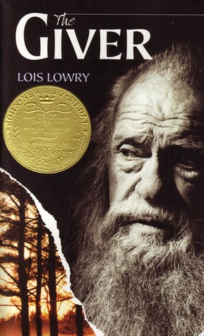
The Giver is a morally driven and interesting story about a young boy called Jonas who lives in a society free of crime and sadness. At the age of 12, children are assigned their jobs, which they will train for and do for the rest of their lives. Everything is chosen; from your parents to your partner. Jonas stands apart from the community when he is chosen to become the new "Memory Keeper". Society has been kept free of all the negative aspects of life because for as long as it has been formed, there has been someone who holds all the bad and good memories of the past within them. This is both bad and good for the inhabitants because, although they are protected from harm, they are also not exposed to the wonderful aspects of life.
I thoroughly enjoyed this book because, even though it is supposed to be more of a children's book than young adult, the storyline is complex enough to hold the attention of older readers. I really enjoyed Jonas as a character because his character development from a scared boy, to someone willing to risk his future to save the community, is enjoyable to follow. This book shows the path of growing up; at first we are scared to accept that there are new responsibilities, but as we slowly get used to it we want to move more and more away from childhood.
Throughout the book, Jonas' loss of trust in his parents is also important in communicating the morals of the story. At the beginning, when Jonas is a normal child in the community, he trusts his parents completely as is expected. However, after The Giver shows Jonas the tape of his Father "releasing" a new born child, a process in which the child is killed and disposed of, Jonas ultimately loses his trust and admiration of his father. This moment is what forces Jonas to leave the community, even before The Giver has planned for him to. I enjoyed this transition in Jonas because he begins to defy the life which is set out for him. It is symbolic of the change from the innocent mind of a child into the questioning and educated mind of an adult.
The ambiguity of the ending is also another aspect which makes this book interesting to read. There are two possible meanings behind the ending; either Jonas and Gabriel freeze to death together on the sled, or they have really found "Elsewhere". Ultimately, the ending still shows us that, whatever happens, Jonas has made choices for himself rather than being told what to do. Whatever happens to him, it is still better than his life in the community would ever have been.
The community is a metaphor for restriction and censoring; it limits the choices of an individual until they have none left, removing joy from life. By leaving the community Jonas has already made an individual choice, and this demonstrates to the reader that it is better to live your life the way you would like to, than be held back by others and never really be happy. I think this is an important message for children and young adults today, as experiences such as bullying in schools limit people from being themselves.
This book was easily read in a couple of hours because of its simple but gripping storyline and its interesting characters. The Giver was so powerful because it's one of a rare few young adult books which leaves the ending up to you. The ending of The Giver is powerful because we have a choice in what it means; just as Jonas made a sacrificial choice for the good of the community, you have to decide for yourself too.
I would recommend this book to anyone who loves dystopian worlds, and well as people who like a book to let them think for themselves!

